Creation of Banner and Navigation Bar Documentation

We decided to have a banner at the top of the page to accompany the navigation bar. This was present on the wireframes that we designed, and so we had to implement it.

To begin, we looked at existing websites. We did not limit ourselves to just e-commerce websites in terms of aesthetic inspiration.

Epiphone banner/navigation bar:



What we liked:

* Simplicity
* Connects nicely to navigation bar

What we disliked:

* No images (logo for example)

TripAdvisor banner/navigation bar:

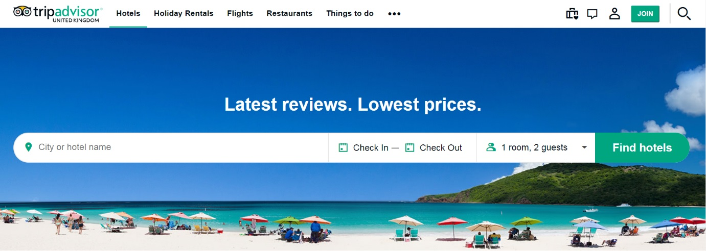

What we liked:

* Very aesthetically pleasing
* Logo in top left of screen

What we disliked:

* Navigation bar position

Twitter banner/navigation bar:

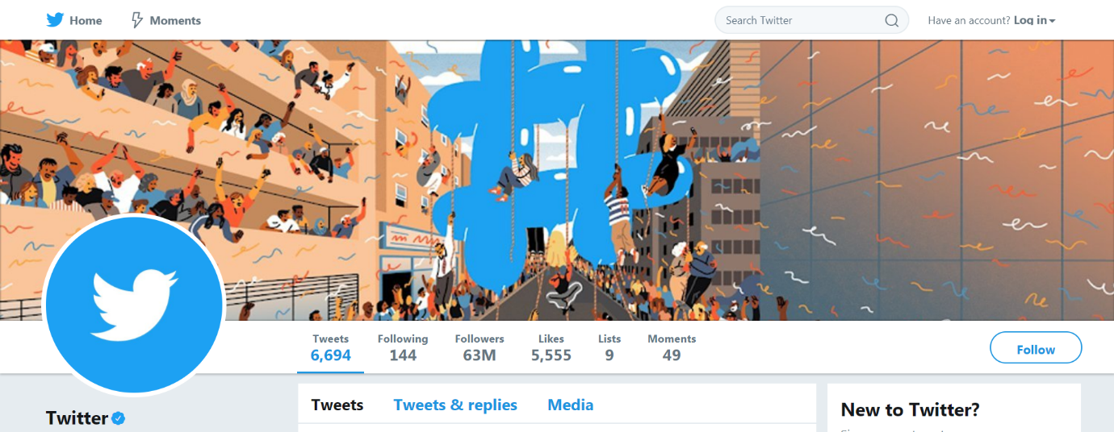

What we liked:

* ‘Login’ option to the right of navigation bar, separated from other options

What we disliked:

* Too many colours

From this, we were able to create criteria for our banner and navigation bar. It was decided that ours should be:

* Visual
* Simplistic
* Include a logo, ideally at the top-left
* Include text that states the name of our site
* The banner and navigation bar should look nice together

This is a simple banner and navigation bar that we designed before going into detail, just to get a sense of what kind of look we wanted regarding fonts, colour schemes, and other such things.

No logo is present here because we did not have it designed at this stage.

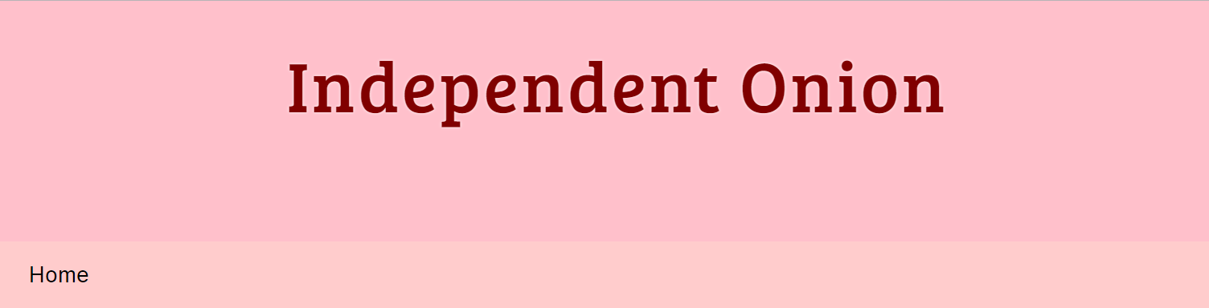

This is a more advanced banner with the navigation bar more populated. A subheading stating ‘est. 2018’ was added to fill a large empty space. The colours were acquired by sampling the colours of different onions. Everyone in our team liked this aesthetic. At this stage it was still missing a logo and some links.

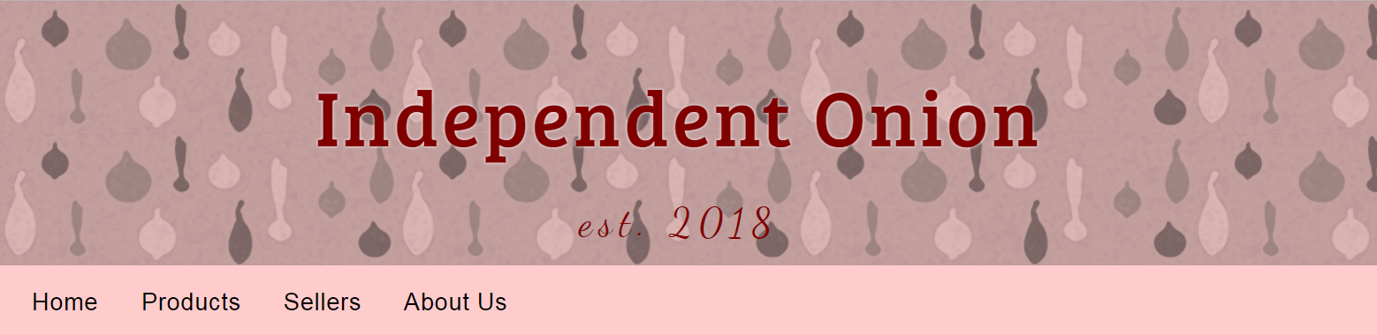

This is the definitive version. We all liked this, and so ceased to modify it further aesthetically.

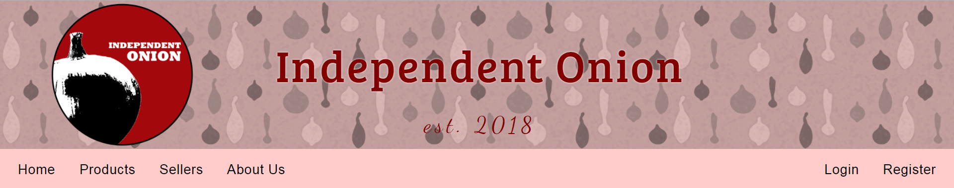

It may also be worth noting that the look changes depending on screen size.

On a medium screen, the text that states ‘est. 2018’ is removed and the title is split onto two lines. This is because not everything could fit onto the screen.

Most mobile devices get this aesthetic.

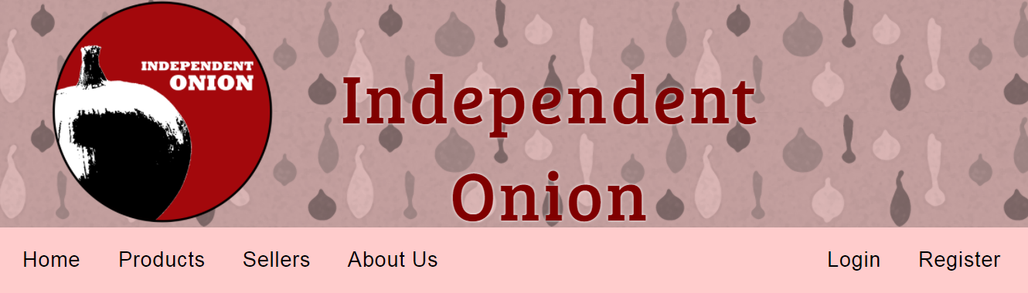

Here’s what it looks like on mobile (banner and navigation bar only):

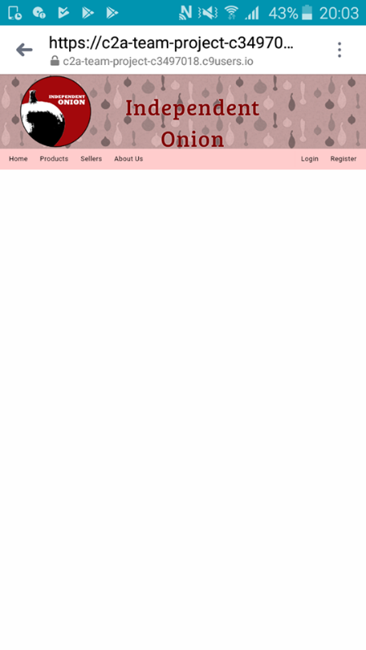

On small screens, the entire title of the website could not fit onto the screen. We initially resized the text, but it was too small to read. We settled on changing the text entirely to something that would fit onto the screen. The navigation bar repositions too due to spacing issues.

